Ballistic Pendulum

Equipment

|  |  |  |
| --- | --- | --- |
| 1 | Rotary Motion Sensor | PS-2120A |
| 2 | Photogate Head | ME-9498A |
| 1 | Mounting Bracket | ME-6821A |
| 1 | Large Table Clamp | ME-9472 |
| 1 | 90 cm rod | ME-8738 |
| 1 | Mini Launcher | ME-6825A |
| 1 | Ballistic Pendulum | ME-6829 |
|  | NEEDED, BUT NOT INCLUDED: |  |
| 1 | 850 Universal Interface | UI-5000 |
| 1 | Meter Stick | SE-8827 |
| 1 | Balance | SE-8723 |

Introduction

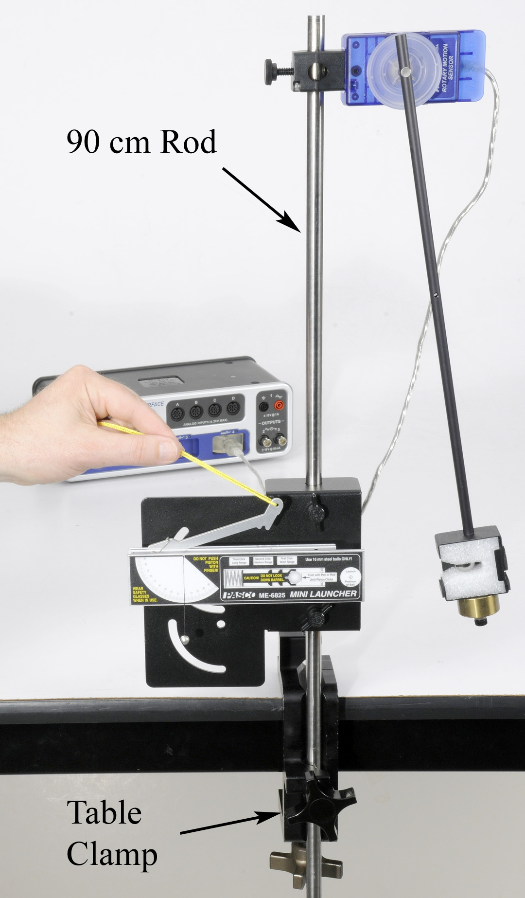A Ballistic Pendulum is used to determine the muzzle velocity of a ball shot out of a Projectile Launcher. The laws of conservation of momentum and conservation of energy are used to derive the equation for the muzzle velocity.

Setup

1. Attach the Table Clamp with 90 cm rod to the table as shown in Figure 1.
2. Figure 2 shows the back side of the launcher bracket. Fasten the launcher to the bracket using the two thumbscrews through the two holes. Do not use the curved slots.
3. Slide the launcher bracket over the rod, and secure with the two thumbscrews on the front as shown.

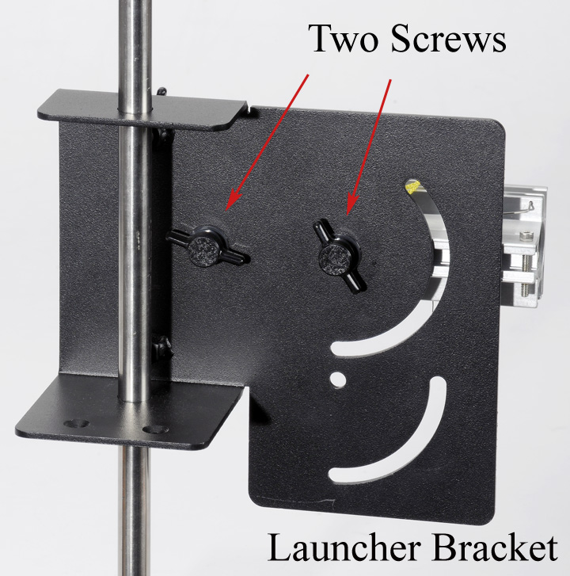

Figure 1: Launching the Ball Figure

Figure 2: Mounting Launcher

1. Attach the 100 g Ballast Mass to the bottom of the pendulum catcher as shown in Figure 3.
2. Slide the Rotary Motion Sensor onto the 90 cm rod, and attach the pendulum to the pulley. Connect the sensor to the interface. Set the sample rate in PASCO Capstone to the default 20 Hz.
3. Create a graph of Angle vs. time.
4. Click on Record, then rotate the pendulum away from the launcher. The angle must be positive. You can change the sign of the angle by using the Rotary Motion Sensor from the other side, or you can change the sign in the properties for the sensor.
5. Adjust the position of the Rotary Motion Sensor so that the square catcher at the bottom of the pendulum aligns with the launcher.
6. If you loosen the two thumb screws on the back of the launcher, you can slide the launcher horizontally. Slide the launcher so that it almost (but not quite) touches the pendulum catcher. Make sure the launcher is set for a launch angle of zero degrees, and then re-tighten the thumb screws.

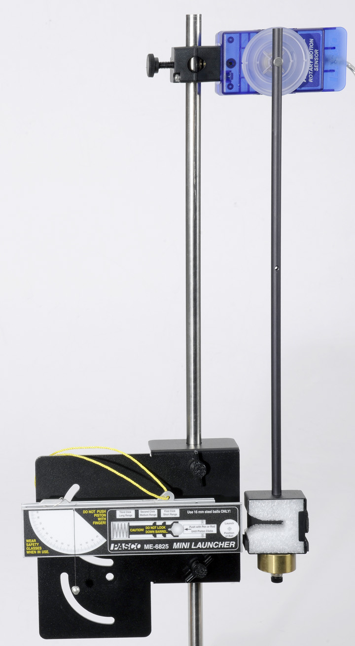 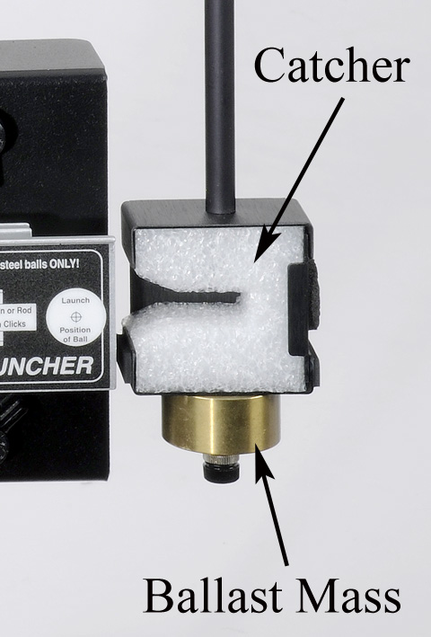

Figure 3: The pendulum must be adjusted so that the catcher is directly aligned with the launcher. When the ball is launched, it is trapped in the slot in the white foam.

Theory

The Ballistic Pendulum has historically been used to measure the launch velocity of a high-speed projectile. In this experiment, a Projectile Launcher fires a steel ball (of mass mball) at a launch velocity, vo. The ball is caught by a pendulum of mass mpend.

After the momentum of the ball is transferred to the catcher-ball system, the pendulum swings freely upwards, raising the center of mass of the system by a distance h. The pendulum rod is hollow to keep its mass low, and most of the mass is concentrated at the end so that the entire system approximates a simple pendulum.

During the collision of the ball with the catcher, the total momentum of the system is conserved. Thus the momentum of the ball just before the collision is equal to the momentum of the ball-catcher system immediately after the collision:

(1)

where vis the speed of the catcher-ball system just after the collision, and M is the combined mass of ball + catcher.

(2)

*During* the collision, some of the ball's initial kinetic energy is converted into thermal energy. But *after* the collision, as the pendulum swings freely upwards, we can assume that energy is conserved and that all of the kinetic energy of the catcher-ball system is converted into the increase in gravitational potential energy.

(3)

where the distance his the vertical rise of the center of mass of the pendulum-ball system.

Combining equations (1) through (3), to eliminate v, yields

(4)

The height, h, of the pendulum is calculated using the angle, θ, and the length of the pendulum, L, as shown in Figure 4. Using trig, it can be shown that

(5)

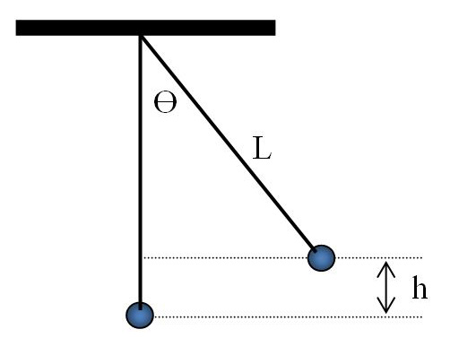

Figure 4: Finding h

The length of the pendulum, L, is measured from the pivot point out to the center of mass of the pendulum. Since in this lab the pendulum is not a point mass, the center of mass is determined by balancing the pendulum on an edge.

Procedure – Measuring Angle

1. Create a table with a user-entered data set called “Max Angle” with units of degrees (o). In the second column, create a user-entered data set called “L” (for length) with units of m. Insert a third column. In the third column, create a user-entered data set called “Launch Speed” with units of m/s. Turn on the statistics with the mean and standard deviation selected.
2. On the Angle vs. time graph, turn on the statistics with the mean selected.
3. To load the launcher, swing the pendulum out of the way, place the ball in the end of the barrel and, using a pushrod, push the ball down the barrel until the trigger catches in the third (Long Range) position.
4. Return pendulum to its normal hanging position and wait until it stops moving.
5. Click on Record and immediately launch the ball so that it is caught in pendulum. There is a Stop condition that should halt data recording.
6. If the ball is not caught, check the alignment.
7. Record the max angle in the table, and repeat several times. Note that the average value is calculated.
8. Repeat until you get a good solid average value for the angle, then record that angle on the next page.

Calculating the Launch Speed

1. Remove the pendulum from the Rotary Motion Sensor, and balance it on a meterstick as shown in Figure 5. Note that the ball is still in the catcher!

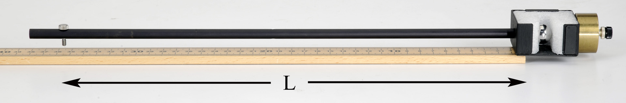

Figure 5: Finding the Center of Mass: Balance the pendulum on the end of the meter stick.

1. Find the point at which the catcher is extended as far as possible out over the edge of the meterstick. When properly balanced, the center of mass is directly over the end of the stick.
2. Record L, the distance from the center of mass out to the pivot (screw). Measure this several times and estimate your uncertainty.
3. Using your average value for L and Equation (5), calculate the height, h.
4. Remove the ball from the catcher and, using a Balance Scale, measure the mass of the pendulum (without ball!) and the mass of the ball.
5. Using Equation (4), calculate the launch speed, v₀, of the ball. Estimate the uncertainty in your value.

Measuring the Launch Speed

1. 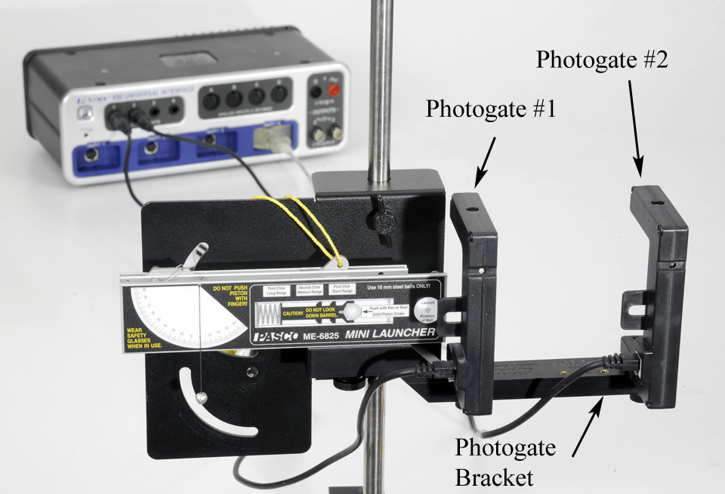Attach Photogates to the launcher using the Photogate Bracket as shown in Figure 6. Slide the bracket so that Photogate #1 is as close to the end of the launcher as possible.

Figure 6: Measuring the Launch Speed

1. Photogate # 1 must be connected to Digital Input #1 and Photogate # 2 must be connected to Digital Input #2. In PASCO Capstone, open the Hardware Setup and click on Digital Input #1 and select a Photogate and click on Digital Input #2 and select Photogate.
2. Open the Timer Setup and choose a Pre-configured timer, select both photogates, Two Photogates (Single Flag), Speed between Gates, and a photogate spacing of 0.1 m.
3. Create a Digits display and select Speed Ch 1&2.
4. Place the ball in the launcher and compress the spring to the third (long range) setting as before.
5. Make sure no one is in the way of the ball! Click on Record and then launch the ball. There is a Stop Condition that should halt data recording.
6. The measured speed is shown in the Digits Display. Record this value in the table, and repeat several times. Note that the average value is calculated.
7. Repeat until you get a good solid average value for the launch speed. Include the uncertainty in your value.
8. Compare to your calculated value using the % error calculation. Did your two answers agree within the uncertainty?